Project: Floating Building (Using two-point Perspective)
Materials: Pencil, erasure, colored pencils, Ruler, 12x18 drawing paper
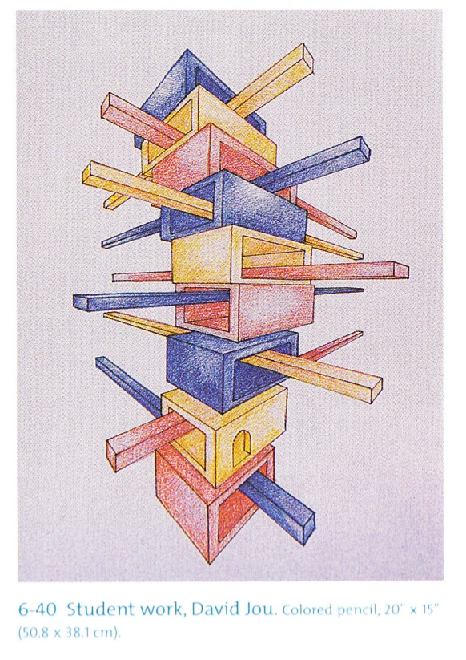
- Imagine a futuristic building where people can fly freely. What does it look like?
- Make sketches in pencil in your sketchbook. Using the two point perspective video as a guide to help you sketch.
- On your 12x18 paper, hold it vertically or horizontally and draw a light horizon line/eye level line across the center of the page.
- Place two vanishing points near the edges of the paper. These points will be at the edges of your horizon line.
- Using a ruler, draw your building, with every horizontal line going to one of the two vanishing points. Make sure to fill your page with a balanced and unified building.
- Use color pencils to add value to your building. Use various color pencil techniques you have learned to develop your building.

