Mixed Media Photo Transfer Painting
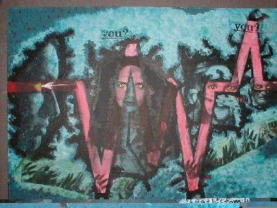
Assignment:
You will be creating a mixed-media painting on a theme of your choosing. By using carefully chosen images, text, color, and painted images, you can create an interesting painting that expresses a political, social, moral, or cultural issue that is of importance to you personally. By selecting a theme about which you feel passionate, you can create powerful images.
Step 1: Select a theme.
- Select a few photos that are about your theme. Photos must be clear, preferably in black and white or high contrast color, and large enough to photocopy. Please!! No tiny images, blurred images, or low contrast photos.
- Your photos will be photocopied or you can print them out. You may use the same image more than once, repeat and change the scale of the image. One or two really good images are much better than a lot of ordinary images.
Step 2: Do a rough draft of your painting in your sketchbook.
- You must create a clear focus. You must select a limited color scheme that illustrates the theme. For instance: if this has something to do with a dark or sad issue, use dark or muted color.
- You must have a rough draft of the composition.
- Use narrative images in paint. Include images that you paint or draw into the composition which tell a story and illustrate your theme.
- Text can be used, but do not LABEL. Allow the viewer to figure out the theme and message from the images.
Step 3: Composition is very important to this assignment.
- Create a focal point (Emphasis) that leads the eye to the most important part of the painting. Fill the space in an interesting way.
- Mixed media means that you can use paint, photos, words, painted images and drawing. All sorts of drawing media can be used: Colored Pencils, Pastels, Oil Pastels, Charcoal, India ink. Even collaged things are allowed.
- The photos must become part of the painting. By layering paint and doing many layers of transparent paint, you cause the photos to become part of a painting. The photos must look like they are floating up from the paint. All borders and cut edges must not be seen. Allow the paint to go right onto the photos. Stain and paint the photos. Just make sure you do not cause the photos to completely disappear.

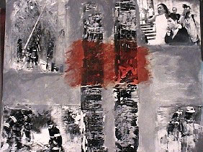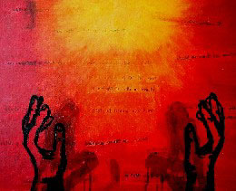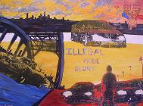

Photocopy Transfer Process:
- Select photographs that are clear and have good contrast.
- Photocopy the photograph (enlarge or reduce if necessary)
- Apply clear Acrylic Gloss Medium to the surface of the canvas and to the surface of the photocopy to be transferred.
- Apply the photocopy to the canvas face down.
- Using a fairly heavy piece of cardboard, rub the surface from the middle of the image, out toward the edges. Excess medium will come out the edges. Press gently and remove all excess glue from surface of canvas.
- Rub the surface of the photocopy gently with fingers which have been slightly moistened with a little water.
- Wait for a few minutes - allow to dry.
- Test the transfer by gently lifting the paper on a corner. If all of the ink is on the Canvas it has transferred. If some of the ink is still lifting off onto the paper, stop and wait another few minutes and try again.
- Gently lift and peel the paper off the Canvas. A thin film of paper will remain on the Canvas.
- Rub the surface gently with moistened fingers. The paper will begin to pill off. Continue rubbing until all of the paper film is removed and the only thing left on the surface is ink. The surface will feel smooth and there will be no white film remaining.
- You can choose to seal the surface with gloss medium, but it is not necessary.
Any text or image that is to be transferred will need to be reversed when printed out. This way the word will come out the correct way on the painting.

Submitted by: Pam Wellington, Boiling Springs H. S., Boiling Springs, PA

