Project: Self-Portrait Stencil
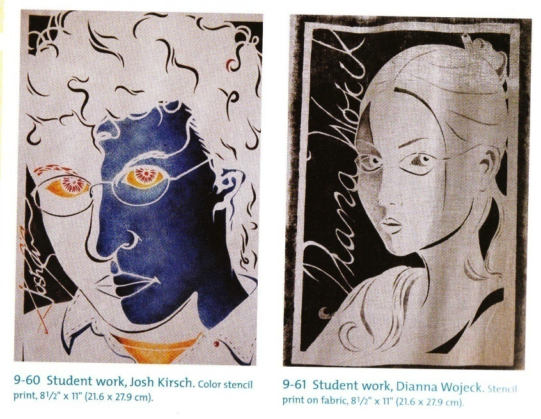
Materials: 8.5x11 white paper, tracing paper, card stock, black acrylic paint, stencil brushes, pencil, x-acto knife.
- Take a head shot photograph of yourself for your self-portrait image.
- Using tracing paper, trace the image of yourself creating a vertical self-portrait. Fill the entire sheet, leaving an area of space to write your name in cursive. Make sure to have a 1” boarder around your portrait.
- Place the tracing paper onto the card stock and trace your drawing onto the board. In the space left, write your name in cursive.
- Decide what is to be cut from the entire picture plane, creating negative spaces from the face. Make sure to create a sense of balance to your portrait. Think about the movement of your hair, the rhythm on your clothes.
- First cut your name, in order to understand which areas can be removed but still maintain integrity and readability.
- Leave boarders determined by the size of your drawing on the board for support. 50% of the finished image will be in positive shapes and 50% will be in negative shapes.
- Practice your print by using scrap paper to determine the amount of paint needed to create a successful print.
- Create a minimum of two prints on 12x18 paper using black acrylic paint.
- Create a third print on piece of fabric using black acrylic paint.
- Create a fourth print on paper using personalized color.
Tip: Use the darker gray to black value scale to create an overall bolder image.

