Project: Self-Portrait Water Color Print
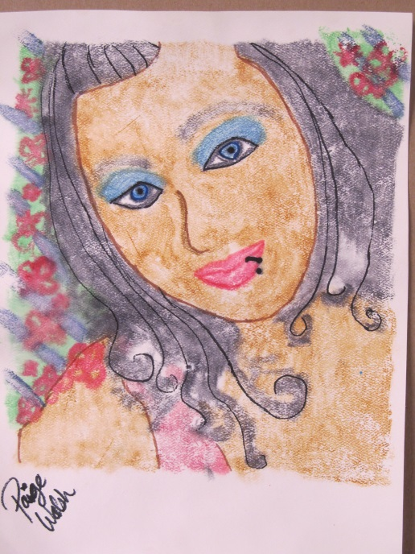
Materials: Selfie photo, Plexiglas, Crayola watercolors, brush, water, 9x12 watercolor paper, sponge
- Take a head shot photograph of yourself for your self-portrait image.
- Have teacher print it out in color for you.
- Place your portrait underneath the Plexiglas as a guide for your portrait.
- Watercolor on top of the Plexiglas. It does not have to be a realistic portrait you can do anything you want (Turn yourself into a cat, Frankenstein, make yourself purple, etc. Be Creative). Don’t use a lot of water, you want the watercolor to be dark and thick.
- Watercolor one area at a time. Let one area dry before applying more watercolors next to it. This prevents the colors running together.
- Let the painting completely dry on the Plexiglas.
- Take your watercolor paper and dampen (lightly wet) it. This is very important. If your paper is too wet it will run all the colors together, if it is too dry it won’t transfer the color.
- Take your damp paper and place it face down (wet side down) on top of your painting.
- Gently rub the paper to transfer the watercolor onto your paper. Make sure you do not move your paper once it is face down.
- Pull your print off of the Plexiglas by lifting your paper.
- Let your paper completely dry.
- Add sharpie lines for texture and finer details once it is dry.

