Water Color with Pen & Ink Lines
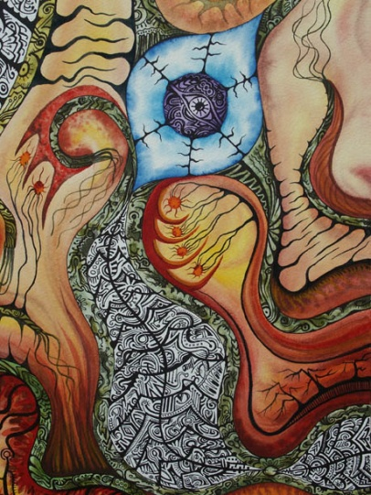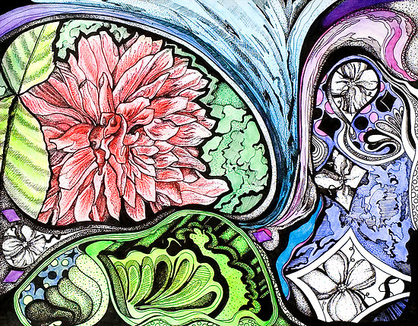
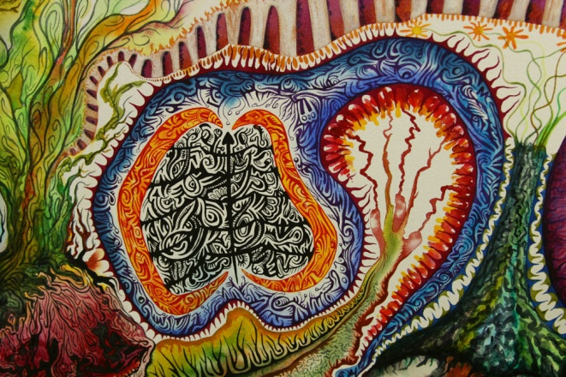
Materials: 11x14 watercolor paper, watercolors, pencil, sharpies
Procedure:
- In your sketchbook divide a sheet into six sections and create six contour line drawings using sharpie (See 2.)
- Each section should contain descriptive and expressive lines. Include: Hatching, Cross Hatching, curved, jagged, straight, diagonal, etc.
- Take a test strip of watercolor paper and practice watercolor techniques. Wet on wet, wet on dry. Experiment and see what you like.
- Sketch out 3 separate designs.
- Will you be using bold contour lines, thin lines. Will your work represent (realistic) something or be non-representational (abstract) like Kandinsky’s work?
- Make sure you plan your balance arrangement. Will it be Symmetrical, Asymmetrical or Radial?
- Use watercolor to paint your background for your line drawing.
- Wait for your watercolor to dry and then lightly draw with pencil your lines.
- Once your lines are drawn use a sharpie emphasize your contour lines.

